

**Wentworth Institute of Technology**

**Department of Applied Math**

**MATH2100-06**

**Probability and Statistics for Engineers**

**Final Project**

**Gabby Gantt, Chelsea Dillon, Matt Chapman**

**Date 4/16/19**

**Professor: M. Takeuchi**

1e) **How much do boxplots vary?**

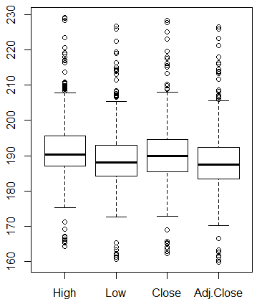

Figure 1: Box Plot for AAPL Stock

The average variance for this stock is not very much. The means for the above boxplot have a variance of at most $10. All the single points are the outliers for the data. Given how much stock fluctuates over the course of a year it is reasonable to see this type of density. Apple’s stock changes very frequently and drastically, so we have a large number of outliers in our data.

**1h) Histogram**

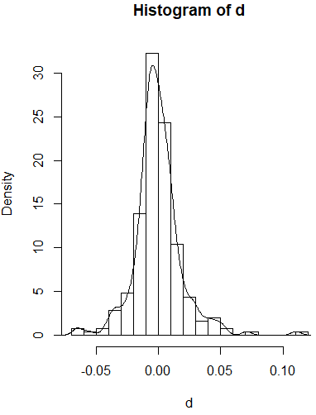

Figure 2: Histogram

**1i) Does it appear it could be from a normal distribution? Explain why or why not.**

Yes, the graph appears to be from a normal distribution. The bell curve centered around the mean, which in this case is approximately 0. There are a few outliers which seem to be skewing the graph slightly to the right but overall its centered around 0.

**1j) Stem and leaf plot**

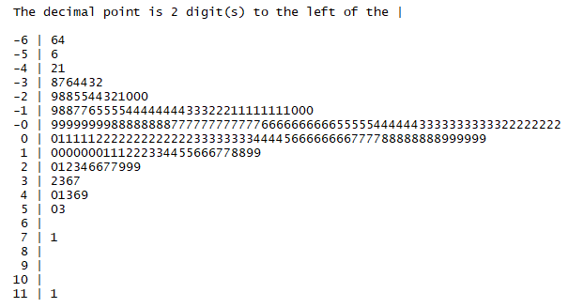

Figure 3: Stem and leaf plot

**1l) Based off of the QQ plot, does the data appear that it could be from a normal distribution? Explain why or why not.**

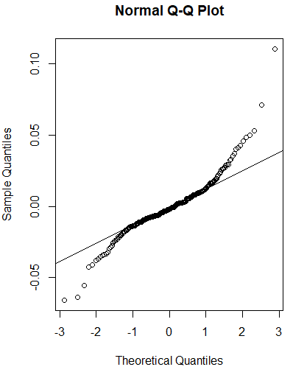

Figure 4

Yes, the data appears to be from a normal distribution. The line mostly follows the plots except for the few outlies on the top and bottom of the graph.

**1m) Do the Shapiro Wilk test on this set of data with level of significance alpha = 0.05. What is the conclusion of the test? Be specific about exactly what the conclusion is.**

W = 0.91813, p-value = 1.624e-10

The p-value is so small due to the number of outliers we have in our data. However, because the p-vale is less than alpha we reject the null hypothesis.

**2)95% CI**

Upper: mu+qt(1-.05/2, df=length(d)-1)*sigma/sqrt(length(d))

-0.003519

Lower: mu-qt(1-.05/2, df=length(d)-1)*sigma/sqrt(length(d))

-0.00453

**3a) Describe the graph you see.**

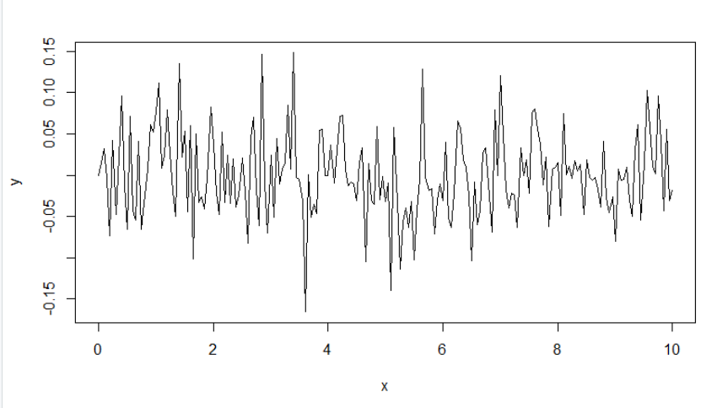

Figure 5: Standard Deviation 0.05

This graph looks noisy with standard deviation at 0.05.

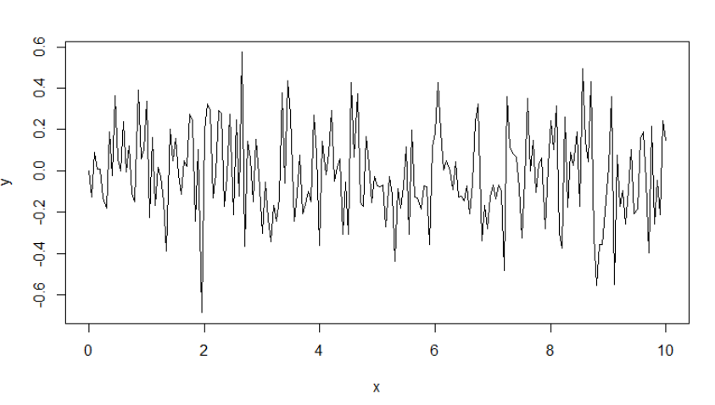

Figure 6: Standard Deviation 0.25

This is what the graph looks like when the standard deviation is changed to 0.25. By doing this it increased the standard deviation and the frequency of the graph.

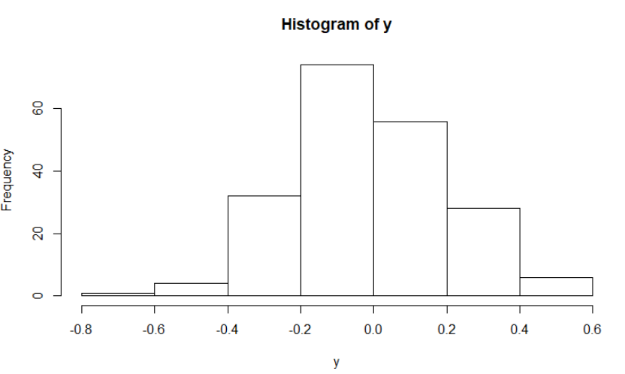

Figure 7

**3b) Compare this plot to the last one. Again, try changing the standard deviation**

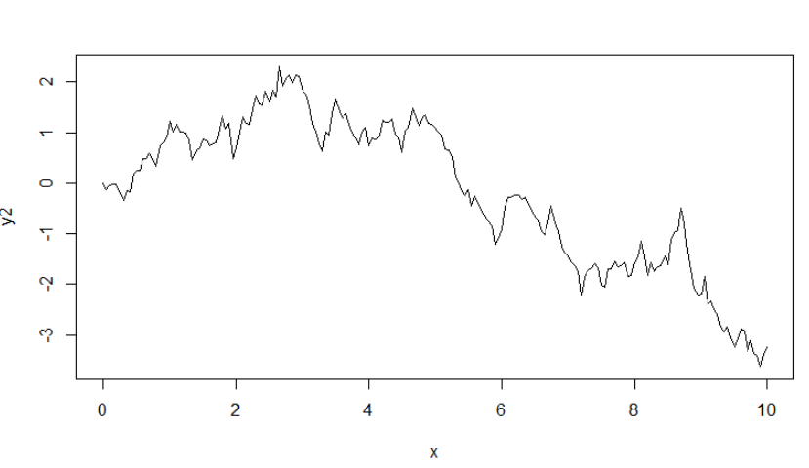

Figure 8: Standard Deviation 0.25; Mean 0

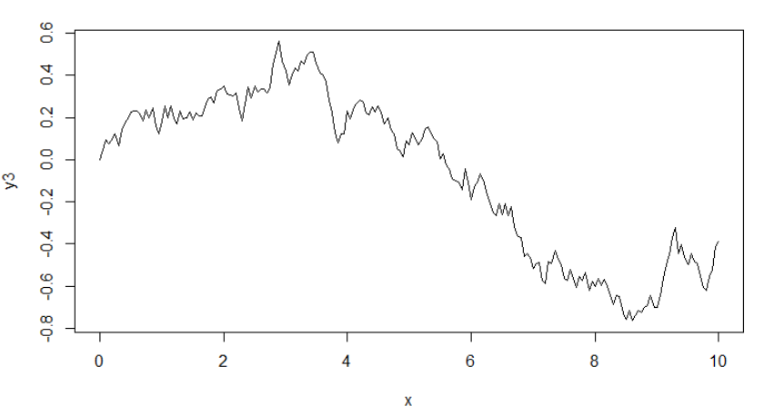

Figure 9: Stand Deviation 0.05; Mean 0

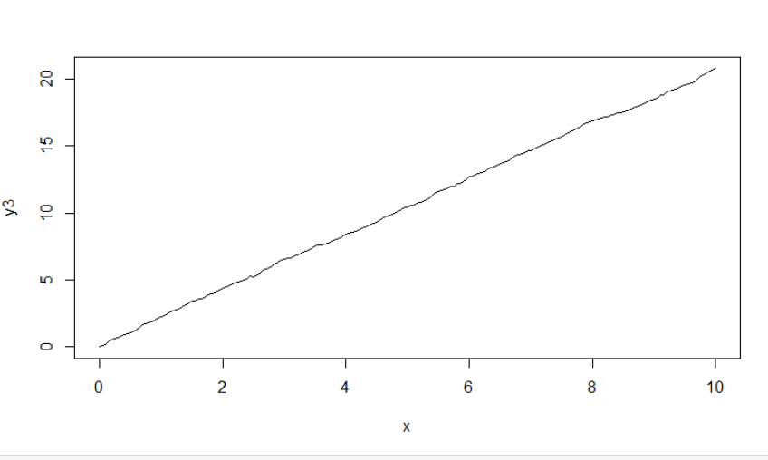

Figure 10: Standard Deviation 0.05; Mean 0.01

Compared to the last graphs these appear to have less noise and have a more concise trend. When the mean was changed to 0.1 the trend became linear.

**4a)**

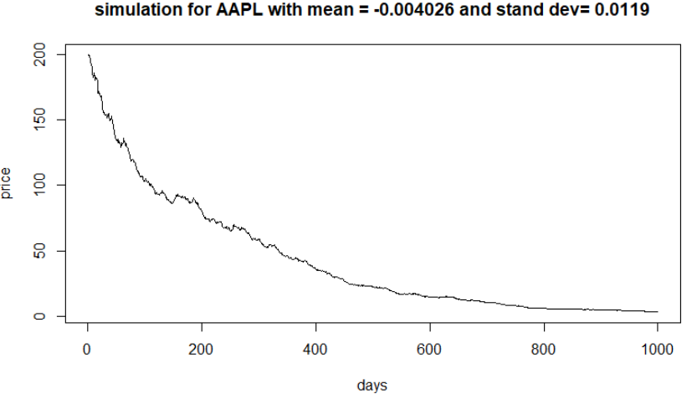

Figure 11: Sigma 0.019 (calculated in step 1k

**4b)**

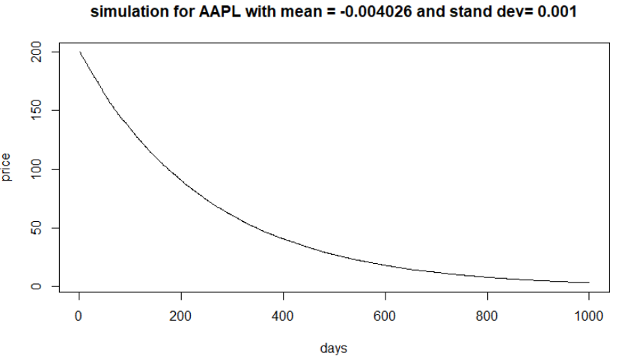

Figure 12: Sigma 0.001

**4c)**

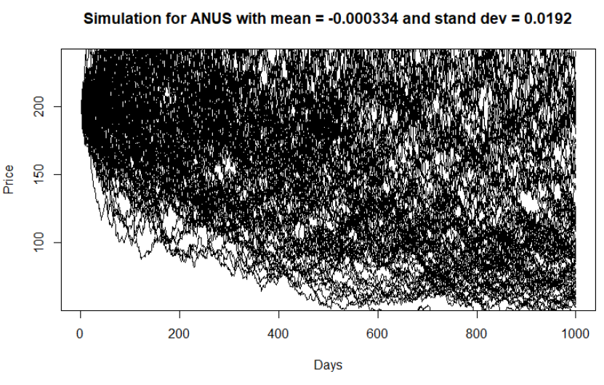

Figure 13



Figure 14